WELCOME TO CHENNAI TOLL PLAZA

G.JAYA CHANDRA

RA2111026010476

CSE (AIML)

Y2SECTION

#include <stdio.h>

#include <conio.h>

#include <math.h>

int main()

{

int choice, vehino;

int r;

printf("########################################################################################################################\n");

printf(" \t\t\t\t\*WELCOME\*\n");

printf(" \t\t\t\*CHENNAI TOLL PLAZA\*\n");

printf(" \t\t\tVEHICLE TYPE SINGLE TRIP RETURN WITHIN 24HOURS MONTHLY PASS \n");

printf(" (Per VECHILE) (PER VEHICLE) (Per VECHILE)\n");

printf(" 1.\t\t\tCAR/JEEP Rs.70 Rs.35 Rs.2075\n");

printf(" 2.\t\t\tBUS/LORRY Rs.95 Rs.60 Rs.4225\n");

printf(" 3.\t\t\tLCV Rs.105 Rs.80 Rs.9025\n");

printf(" 4.\t\t\tCONTAINERS Rs.150 Rs.120 Rs.12840\n");

printf("########################################################################################################################\n\n");

printf("\nENTER VEHICLE NUMBER: ");

scanf("%d",&vehino);

printf("\nSELECT YOUR CHOICE\n");

printf("1.SINGLE TRIP");

printf("\n2.RETURN WITHIN 24HOURS");

printf("\n3.MONTHLY PASS");

printf("\n ENTER YOUR CHOICE:");

scanf("%d",&choice);

switch(choice)

{

case 1:

printf("ENTER VECHILE TYPE : ");

scanf("%d",&r);

if(r==1)

{

printf("######## KADAPA TOLL PLAZA ##########");

printf("\n####### YOUR BILL #######");

printf("\n VEHICLE NUMBER :- %d",vehino);

printf("\nCost for SINGLE TRIP for CAR/JEEP = RS.70");

printf("\n TOTAL AMOUNT TO BE PAID :- 70");

break;

}

else if(r==2)

{

printf("######## KADAPA TOLL PLAZA ##########");

printf("\n####### YOUR BILL #######");

printf("\n VEHICLE NUMBER :- %d",vehino);

printf("\nCost for SINGLE TRIP for BUS/LORRY = RS.95");

printf("\n TOTAL AMOUNT TO BE PAID :- 95");

break;

}

else if(r==3)

{

printf("######## KADAPA TOLL PLAZA ##########");

printf("\n####### YOUR BILL #######");

printf("\n VEHICLE NUMBER :- %d",vehino);

printf("\nCost for SINGLE TRIP for LCV = RS.105");

printf("\n TOTAL AMOUNT TO BE PAID :- 105");

break;

}

else if(r==4)

{

printf("######## KADAPA TOLL PLAZA ##########");

printf("\n####### YOUR BILL #######");

printf("\n VEHICLE NUMBER :- %d",vehino);

printf("\nCost for SINGLE TRIP for CONTAINERS = RS.150");

printf("\n TOTAL AMOUNT TO BE PAID :- 70");

break;

}

case 2:

printf("\n ENTER VECHILE TYPE : ");

scanf("%d",&r);

if(r==1)

{

printf("######## KADAPA TOLL PLAZA ##########");

printf("\n####### YOUR BILL #######");

printf("\n VEHICLE NUMBER :- %d",vehino);

printf("\nCost for RETURN JOURNEY of CAR/JEEP = RS.35 ");

printf("\n TOTAL AMOUNT TO BE PAID :- 35");

break;

}

else if(r==2)

{

printf("######## KADAPA TOLL PLAZA ##########");

printf("\n####### YOUR BILL #######");

printf("\n VEHICLE NUMBER :- %d",vehino);

printf("\nCost for RETURN JOURNEY of BUS/LORRY = Rs.60");

printf("\n TOTAL AMOUNT TO BE PAID :- 60");

break;

}

else if(r==3)

{

printf("######## KADAPA TOLL PLAZA ##########");

printf("\n####### YOUR BILL #######");

printf("\n VEHICLE NUMBER :- %d",vehino);

printf("\nCost for RETURN JOURNEY for LCV = Rs.80");

printf("\n TOTAL AMOUNT TO BE PAID :- 80");

break;

}

if(r==4)

{

printf("######## KADAPA TOLL PLAZA ##########");

printf("\n####### YOUR BILL #######");

printf("\n VEHICLE NUMBER :- %d",vehino);

printf("\nCost for Monthly Pass for CONTAINERS = Rs.120");

printf("\n TOTAL AMOUNT TO BE PAID :- 120");

break;

}

case 3:

printf("\n ENTER VECHILE TYPE : ");

scanf("%d",&r);

if(r==1)

{

printf("######## KADAPA TOLL PLAZA ##########");

printf("\n####### YOUR BILL #######");

printf("\n YOUR VEHICLE NUMBER %d TAKEN MONTLY PASS",vehino);

printf("\n HAVE A SAFE JOURNEY");

}

if(r==2)

{

printf("######## KADAPA TOLL PLAZA ##########");

printf("\n####### YOUR BILL #######");

printf("\n YOUR VEHICLE NUMBER %d TAKEN MONTLY PASS",vehino);

printf("\n HAVE A SAFE JOURNEY");

}

if(r==3)

{

printf("######## KADAPA TOLL PLAZA ##########");

printf("\n####### YOUR BILL #######");

printf("\n YOUR VEHICLE NUMBER %d TAKEN MONTLY PASS",vehino);

printf("\n HAVE A SAFE JOURNEY");

}

if(r==4)

{

printf("######## KADAPA TOLL PLAZA ##########");

printf("\n####### YOUR BILL #######");

printf("\n YOUR VEHICLE NUMBER %d TAKEN MONTLY PASS",vehino);

printf("\n HAVE A SAFE JOURNEY");

}

getch();}

}

Code screenshots :

Screen shot-1

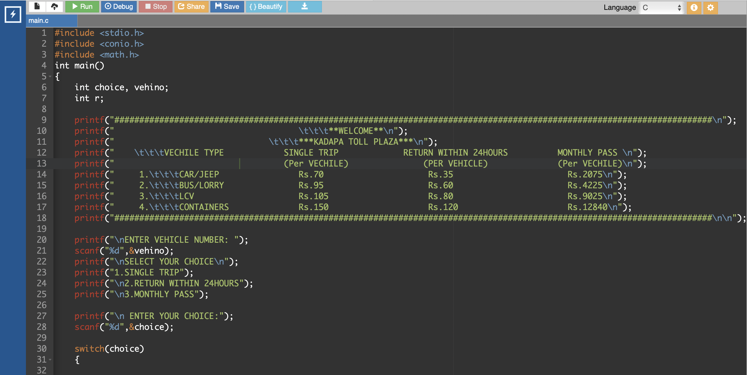

Screen shot-2

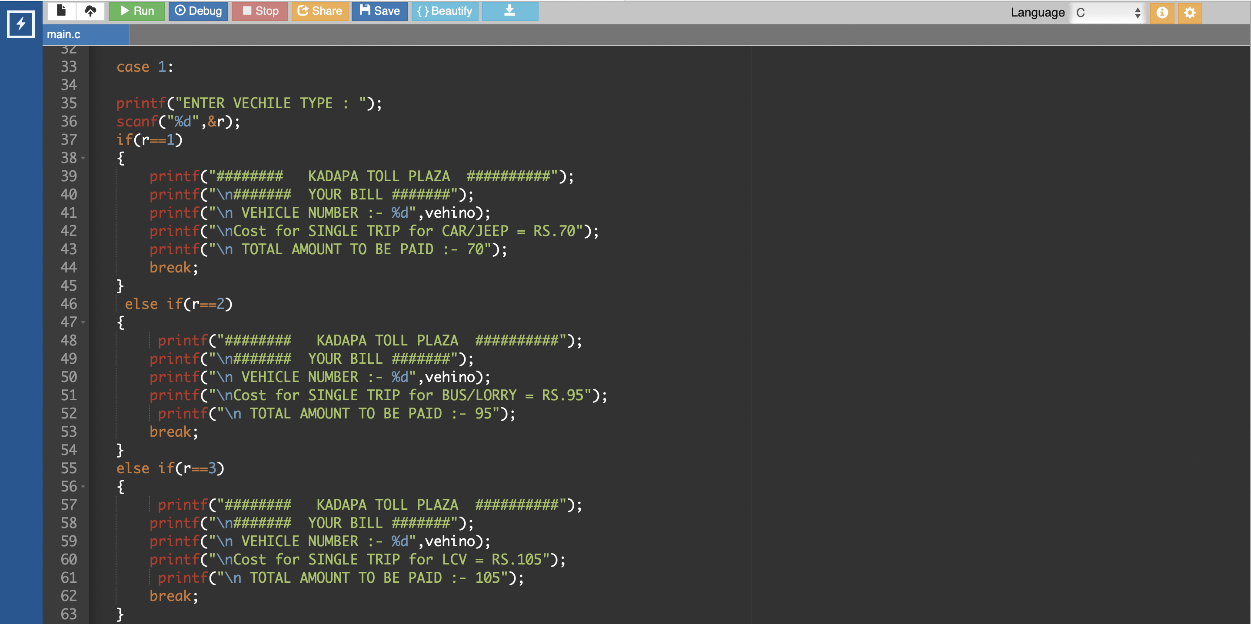

Screen shot-3

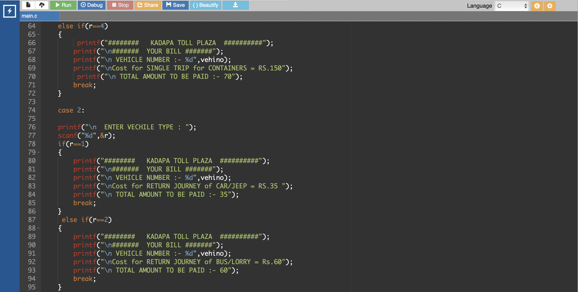

Screen shot-4

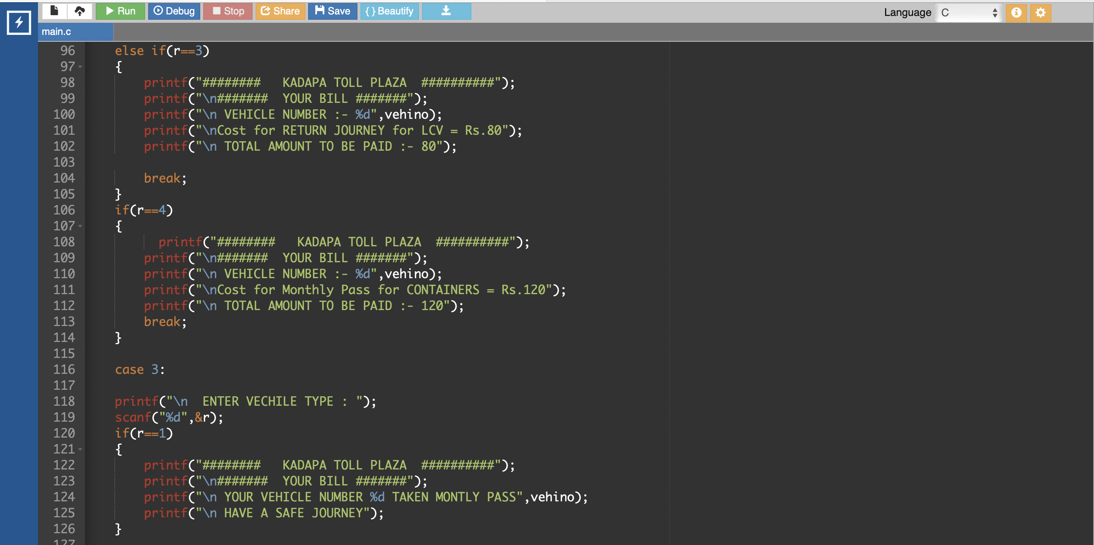

Screenshot-5

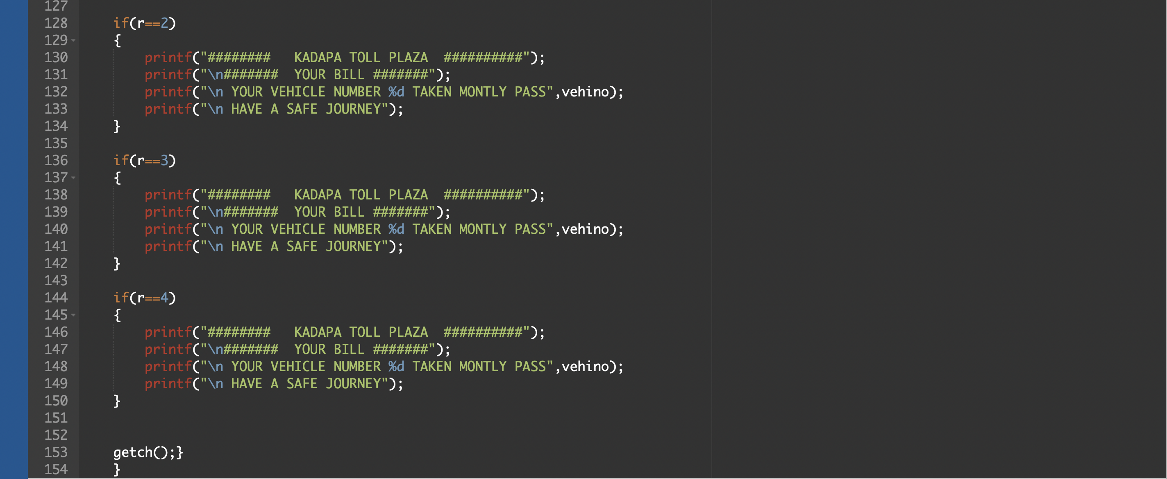

ALGORITHM :-

Step-1:

Start

Step-2:

Initialise variables

Step-3:

Take the input from the user and calculate the price according to route

Step-4:

Case1:Single trip pass

Case 2 : return trip (24 hrs)

Case2:Monthly pass

Case4 :Exit

Step-5:

Display the amount according to the Pass chooses by the user

Step-6:

Stop

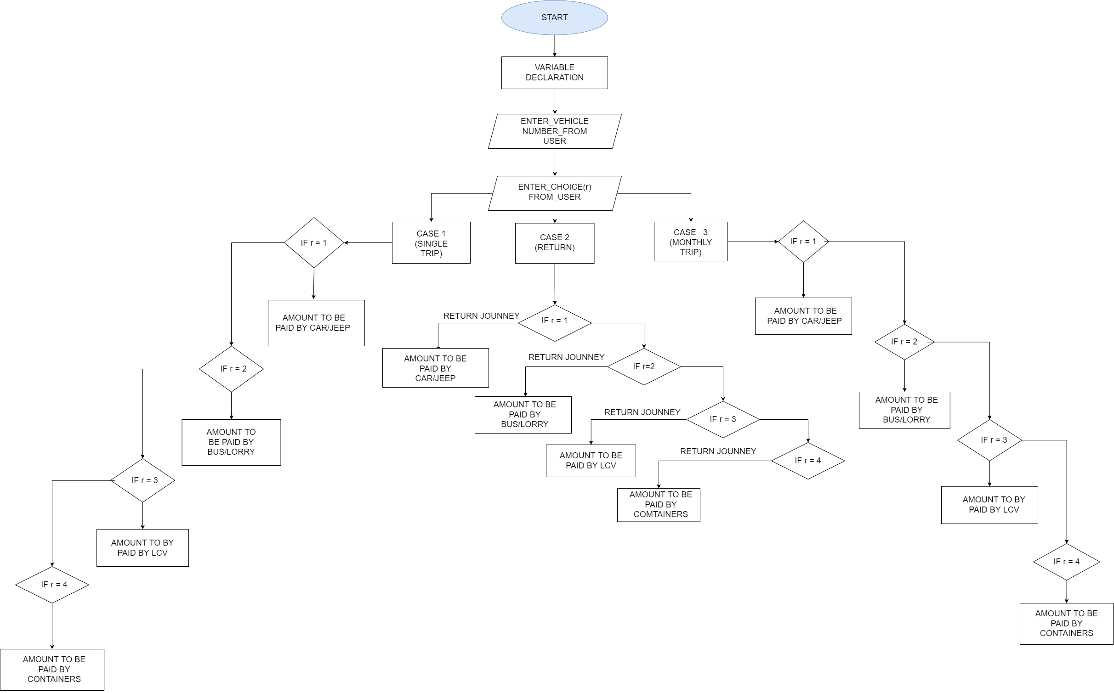 FLOW CHART

OUTPUT SCREENSHOTS :-

SCREENSHOT - 1

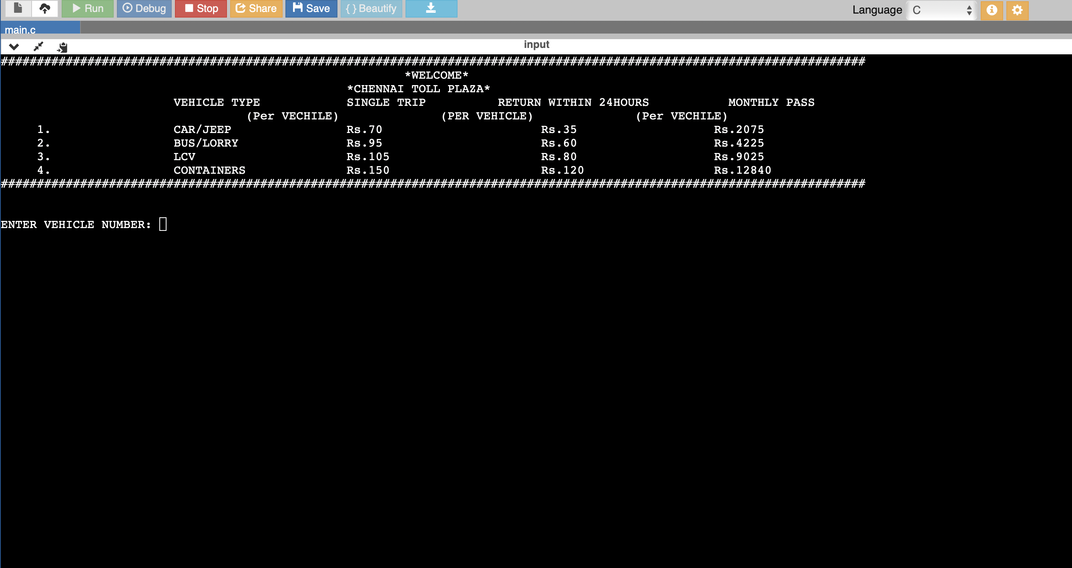

SCREENSHOT-2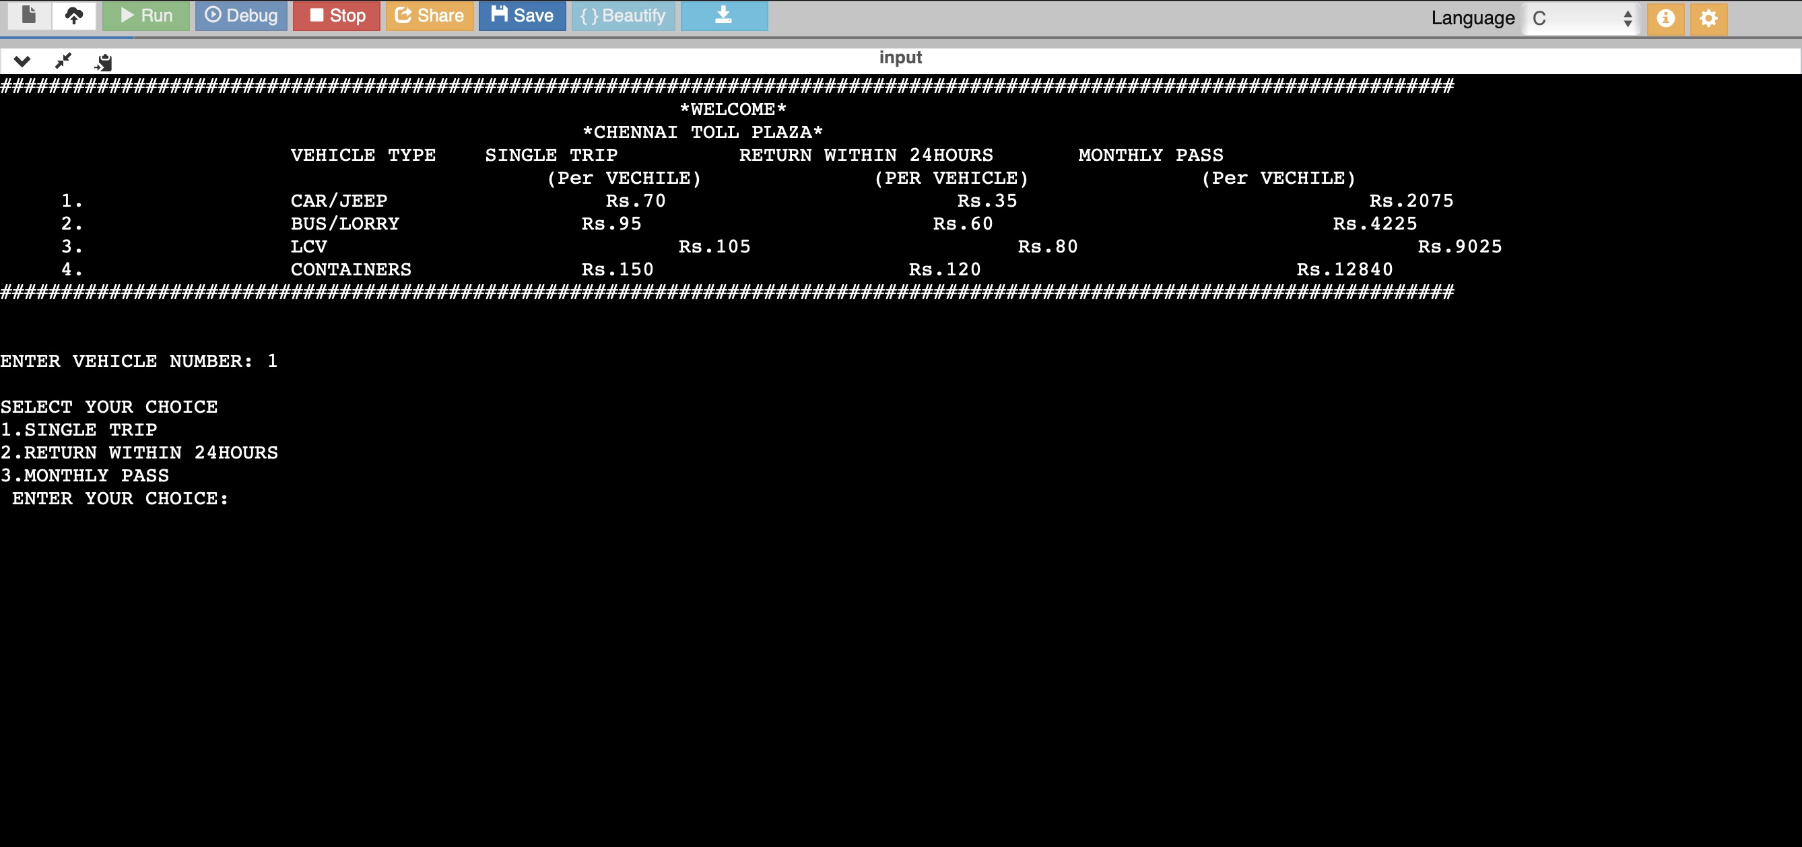

SCREENSHOT-3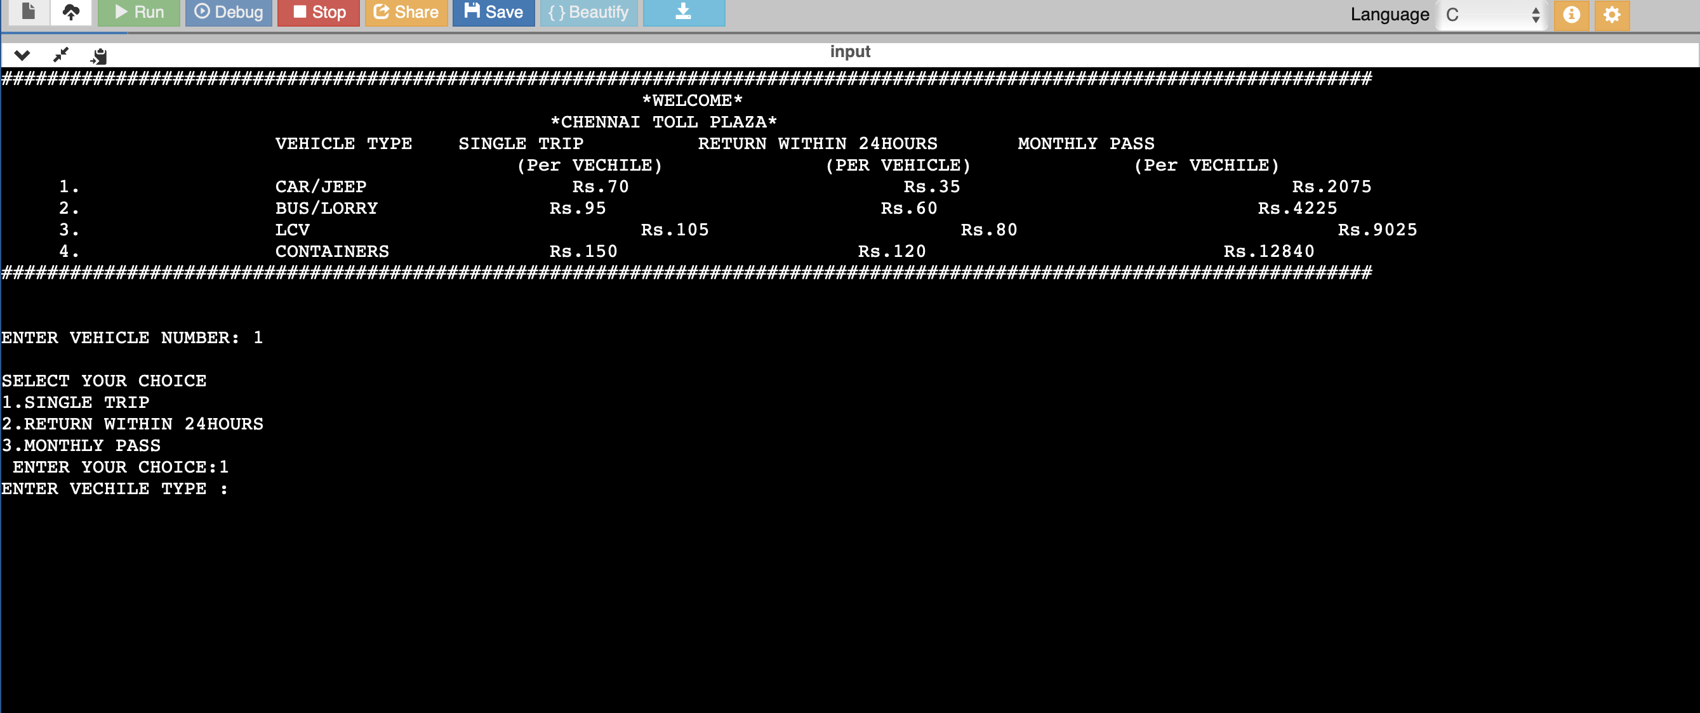

SCREENSHOT - 4